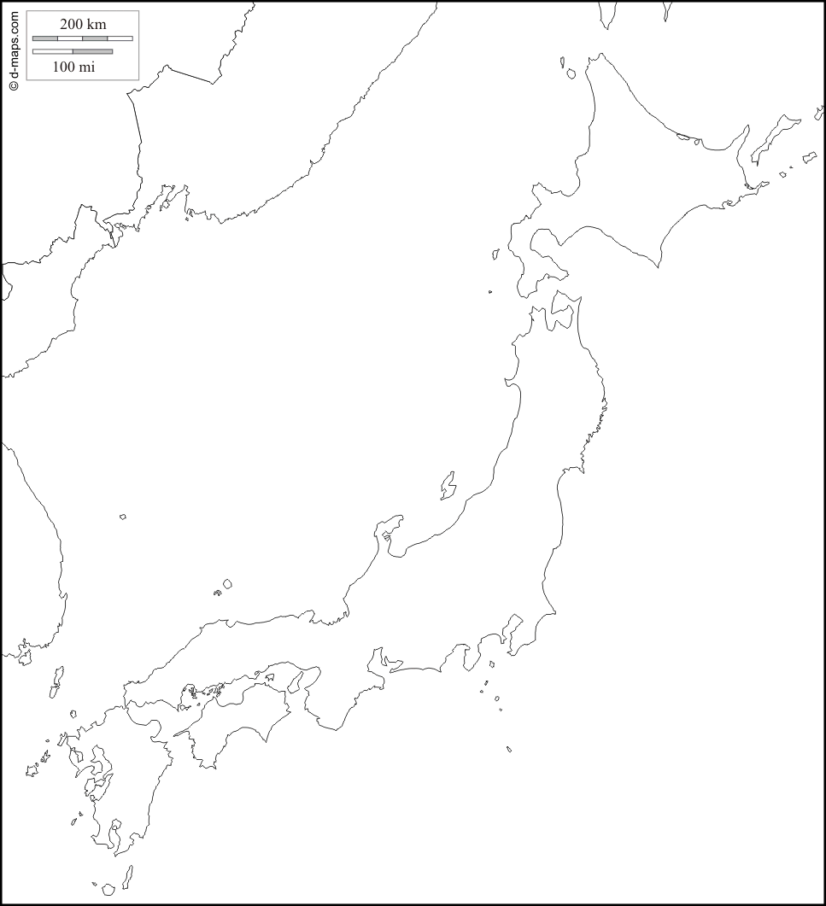
Introduction to Japan
- Using Source 1 (page 226) copy important features and label the map above. (Islands, Seas, Cities, Oceans, Compass Rose)
- Which island is the largest?
__________________________________________
- Which island is the smallest?
__________________________________________

Ancient and Classical Japan
About twelve thousand years ago, Japan was joined to the Asian mainland by several __________________ ________________________. The nomadic hunters and fisherman who walked across them on expeditions became Japan’s first __________________. However, at the end of the last ice age, Earth’s climate warmed and rising oceans covered the land bridges. The islands that formed became the Japanese ______________________ we know today. Later, attracted by the islands’ natural _________________ and rich ________________, sea-faring peoples from various parts of Asia reached Japan by _________________. As their settlements spread, the original inhabitants were gradually driven into the far northern __________________.

Geography of Japan
Read “Geography of Japan” (page 226) and answer the following questions:
- What is Japan made up of?

- What is Japan situated in? what frequent geographical events does it experience?

- Describe Japan’s environment in terms of a) geographical features b) climate c) flora (trees and forests)

The Yamato State
What did the Yamato clan set up around 4th century CE and what did they become as a result of this?

Strengthening the State
What evidence is there that Japan borrowed much of its culture from China?

What happened by the eighth century in the capital city of Nara?

Where did most people still live?

The Heian Period and the growth of the miltary
What happened in 794 AD?

How long did the Heian Period last for?

Who were the Daimyo? What did they do?

What was a Samurai?

What did the title “seii taishogun” mean?

Who did the title belong to and what did it give him?

What was the title later shortened to?

